1) Slack and xMatters Integration url:

https://support.xmatters.com/hc/en-us/articles/209703083?_ga=1.151598841.1337942548.1484212462

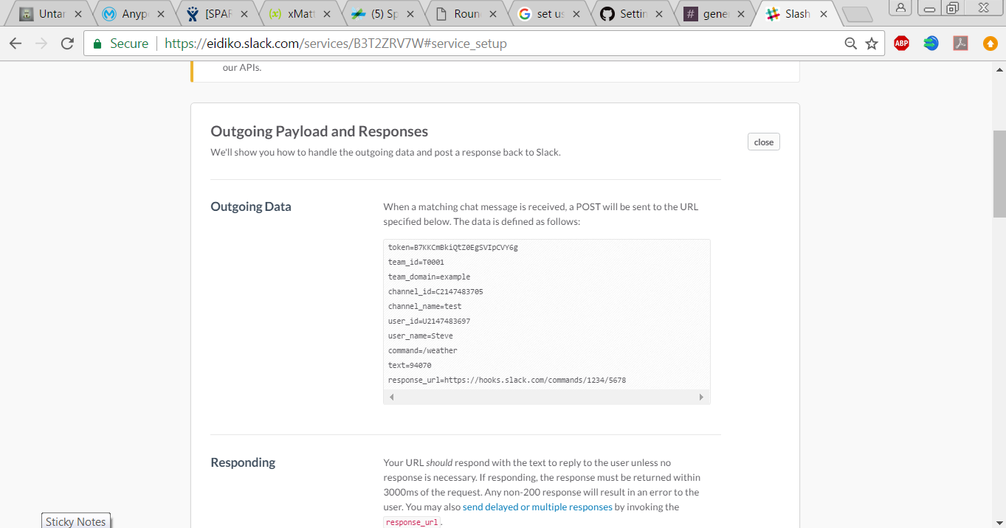

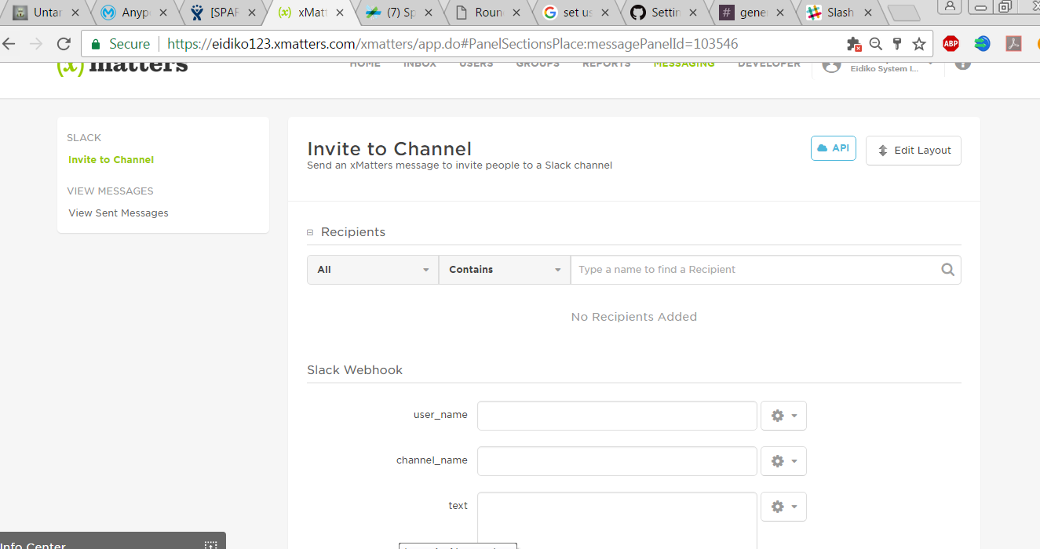

2) Creating an event from slack :

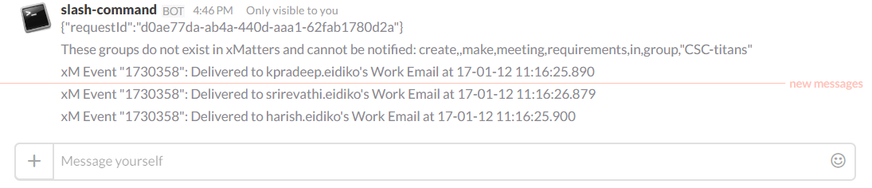

3) Event Details In xMatters :

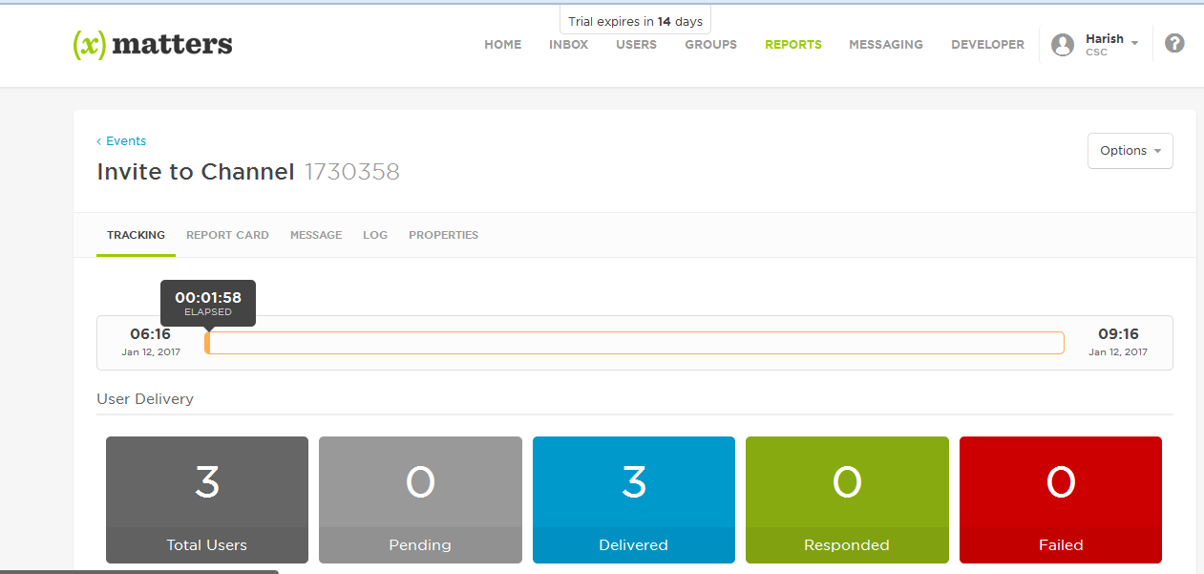

4) Email Received :

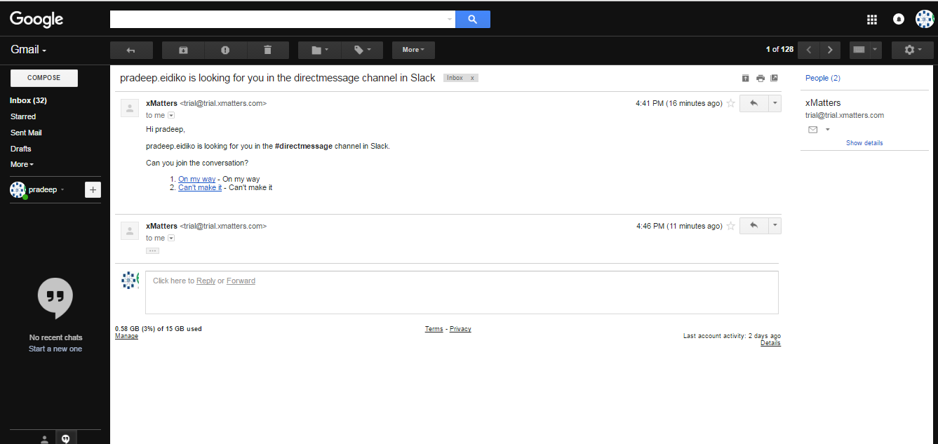

5) Email Response Message in Slack :

